Android Building on Beaglebone (Linux)

Install package: **sudo apt-get install git-core gnupg flex bison build-essential zip curl zlib1g-dev libc6-dev-i386 libncurses5 lib32ncurses5-dev x11proto-core-dev libx11-dev lib32z1-dev libgl1-mesa-dev libxml2-utils xsltproc unzip fontconfig**

You’ll need to have Oracle Java JDK 6 installed in your build environment.

**$ sudo add-apt-repository ppa:webupd8team/java**

**$ sudo apt-get update**

**$ sudo apt-get install oracle-java6-installer**

Once this install has completed, check out the installed Java version:

**$ java -version**

java version "1.6.0_45"

Java(TM) SE Runtime Environment (build 1.6.0_45-b06)

Java HotSpot(TM) 64-Bit Server VM (build 20.45-b01, mixed mode)

Before you get started, you should make sure that you are using a **64-bit** machine and have at least **45 GB** of available disk space to hold the BBBAndroid source, intermediate build files, and final images. You'll also need **6 to 8 GB of RAM** to accommodate the memory requirements of the build process. Once you've verified that you meet these requirements, it is time to get started.

Download the **repo** tool and install it somewhere convenient in your system where it will be in your path:

**$ mkdir ~/bin**

**$ PATH=~/bin:$PATH**

**$ curl https://storage.googleapis.com/git-repo-downloads/repo > ~/bin/repo**

**$ chmod a+x ~/bin/repo**

You could also copy **repo** to /usr/local/bin or the like, though I would discourage you from doing so.

**Building BBBAndroid**

Create a directory to build BBBAndroid in. This will be the "root" of the build:

**$ mkdir bbbandroid**

**Change into the root and clone the BBBAndroid source code:**

**$ cd bbbandroid**

**$ repo init -u http://github.com/hendersa/bbbandroid-manifest**

**$ repo sync -c**

**Once the code has downloaded, run the patch.sh script. This script will patch a few files belonging to the AOSP repos.**

**$ ./patch.sh**

It is time to begin building BBBAndroid. Setup the environment of your shell for building and then configure the build to use the BeagleBone Black device files:

**$ . build/envsetup.sh**

**$ lunch beagleboneblack-eng**

Then, begin the build with make. The -jX option for make will build X files concurrently. Even if you only have a single-core CPU, you should use at least -j2 (as much of the build process is I/O-bound, rather than CPU bound). If you want to use a much higher X for your build, go for it. The more resources (RAM and CPU cores) that you have, the more compilation processes that you can execute concurrently and the shorter the build process will be.

**$ make -j4**

Once you give repo sync your code starts building.

Below are some of the errors that we come across (attaching screenshot)

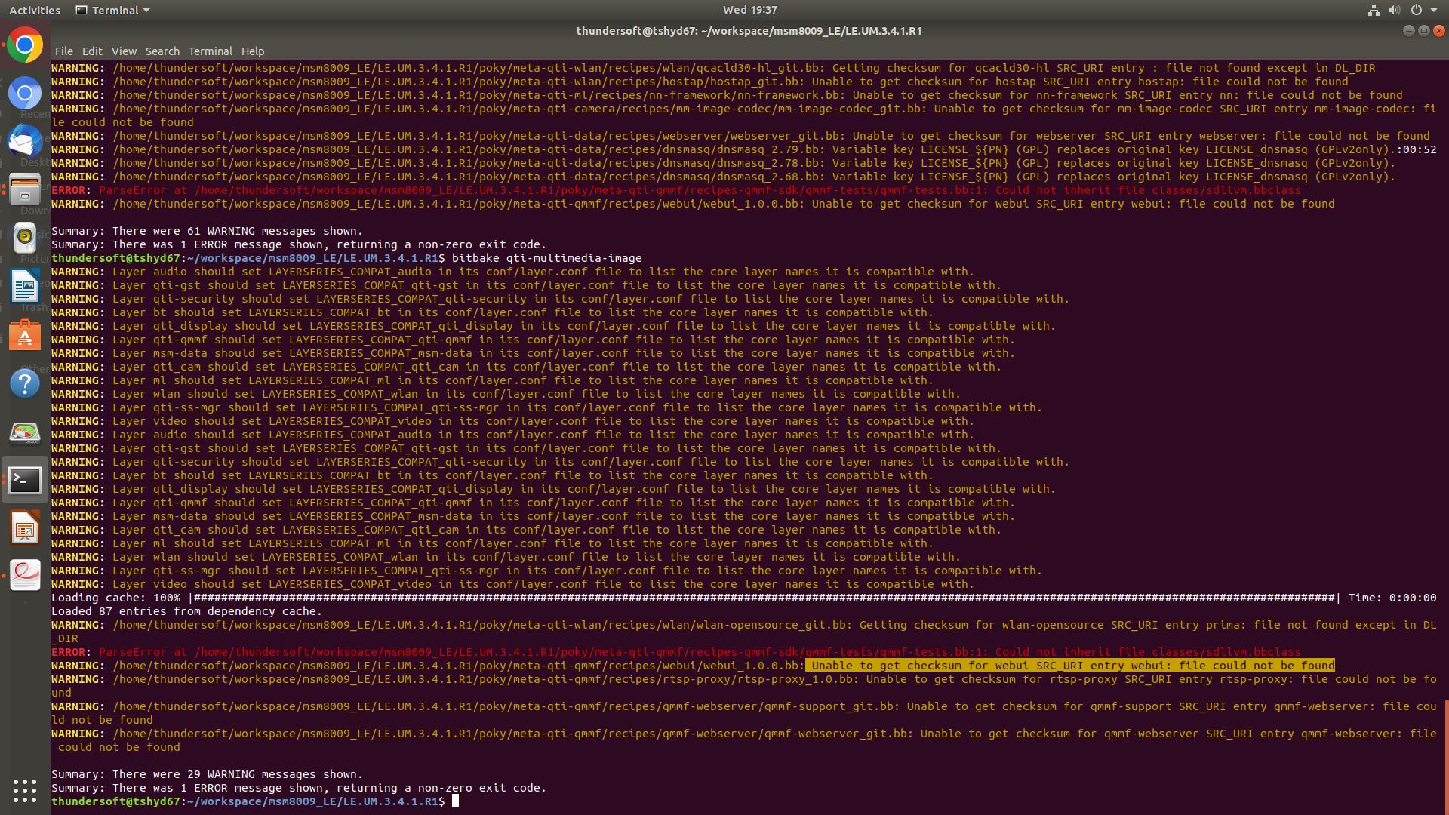

**Solution for above error:** This error is caused because of some missing files so error has checked some word in it.

So to debug this error we need to copy files from LE to LA from poky.

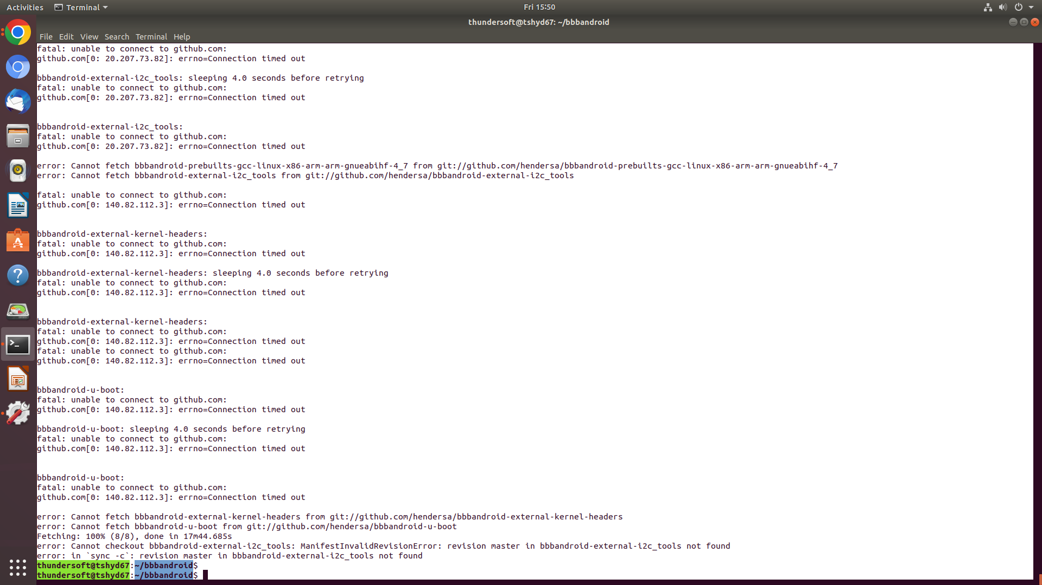

Solution to above error: **Timeout: Above** error causes due to inactivity if you are leaving PC to clone then change settings to never sleep

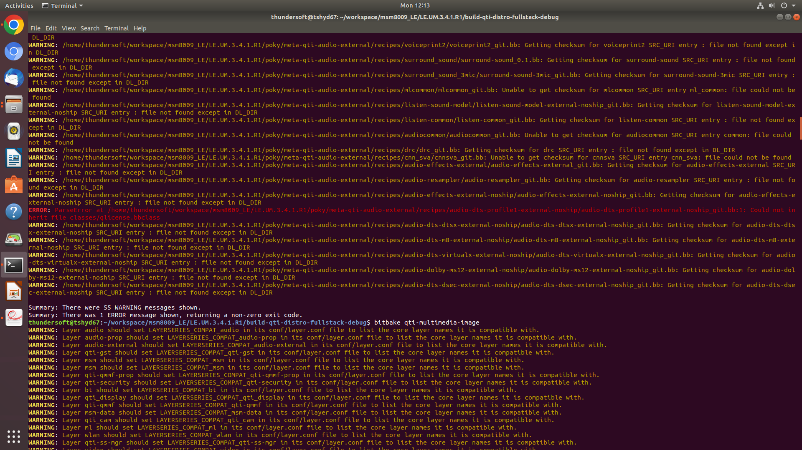

Solution to above error: Parse error means in the above process you are asked to add few lines in specified files,

If added line is not correct you get the above parse error.

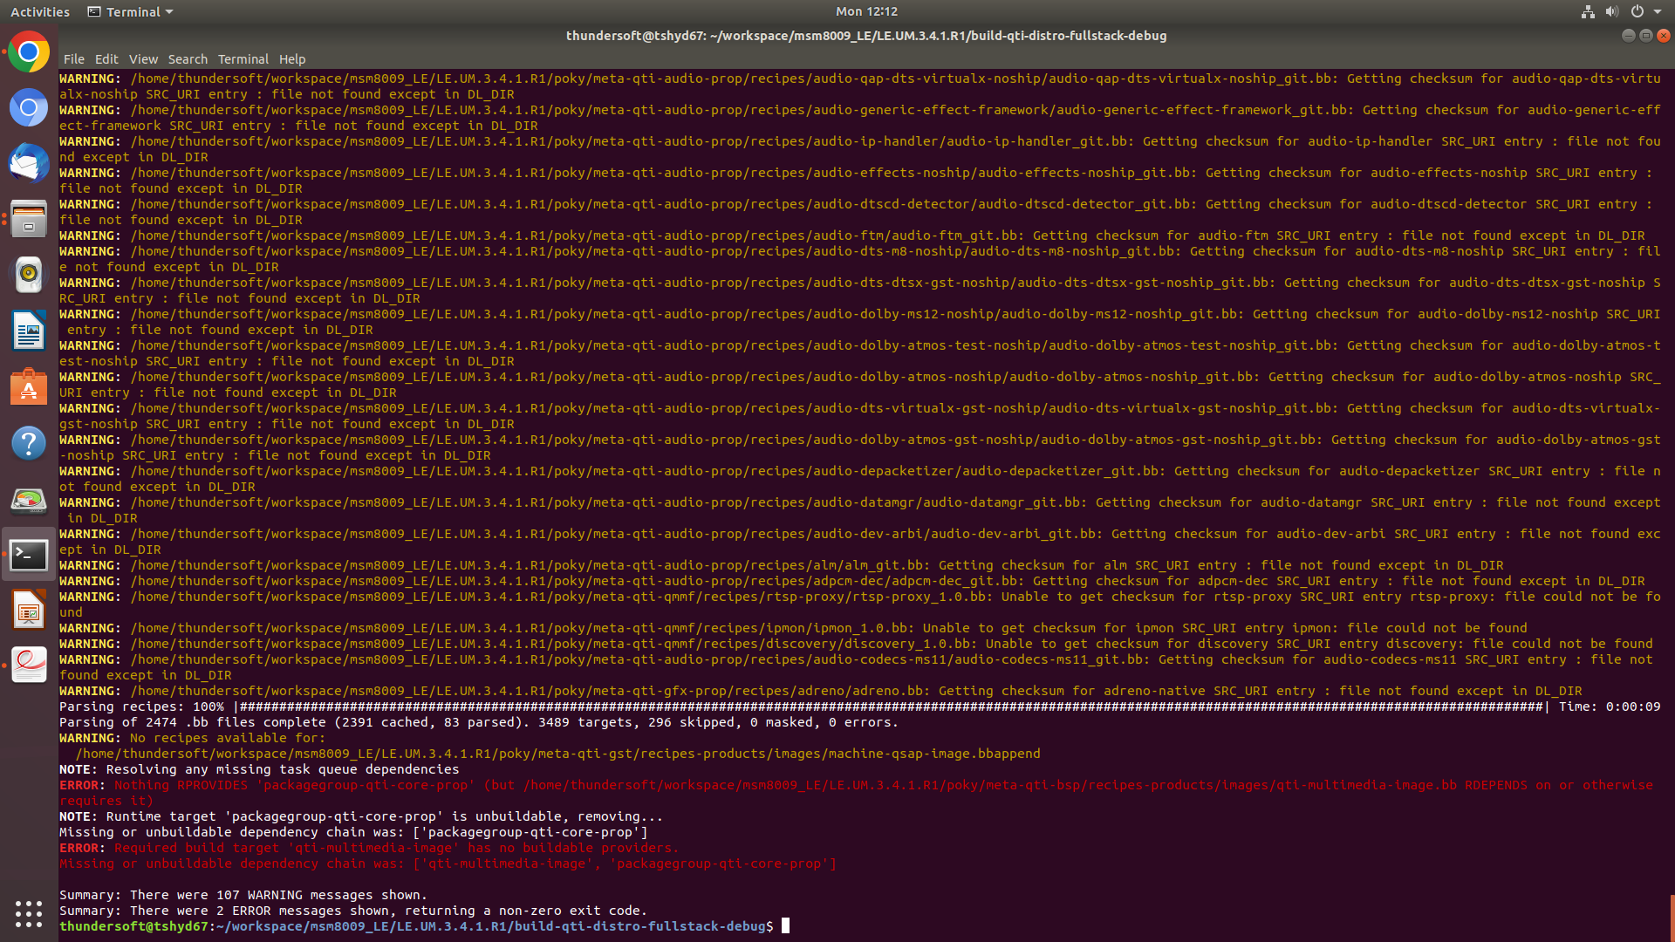

At last when you give bit bake command to create Image it starts building, during process we get above error,

Here we need files specified in braces in above pic.

Link

<https://bbbandroid.sourceforge.net/build.html> open this link and go through the detailed guide.